

**IoT-based smart onion storage project**

**Objective**

The IoT-based smart onion storage project is designed to address several critical post-harvest issues, such as rotting, sprouting, weight loss, and decay, which significantly affect the quality and shelf life of onions. Traditional storage methods often fall short in maintaining the optimal environmental conditions required to preserve the freshness of onions, leading to considerable economic losses for farmers and suppliers. The primary factors influencing the degradation of stored onions are temperature and humidity fluctuations, both of which contribute to spoilage if not properly controlled. This project aims to mitigate these risks by developing an IoT-enabled smart warehouse system that can continuously monitor and regulate these key environmental conditions, thus significantly extending the shelf life of onions from the typical 3 months to as long as 10 months.

Onions are a staple crop, widely consumed across the globe. However, due to their sensitivity to abiotic factors like heat, moisture, and poor ventilation, the post-harvest storage of onions is often a challenge, especially in regions with hot climates. Temperature fluctuations lead to sprouting and decay, while excessive humidity fosters fungal growth and rotting. The traditional storage facilities, often relying on manual intervention, lack the precision and real-time feedback required to control these factors effectively. As a result, farmers and suppliers suffer significant losses during storage. To address these challenges, the proposed IoT-based smart storage solution introduces an automated and data-driven approach to optimize the storage environment.

The primary objective of the project is to develop a smart storage system that uses IoT technology to regulate critical parameters such as temperature and humidity. The system is designed to keep temperature levels between 25°C and 30°C and humidity between 65% and 70%, both of which are ideal for extending the longevity of onions in storage. The smart storage system will consist of several key components: sensors, microcontrollers, control mechanisms, and cloud connectivity. The sensors will continuously monitor environmental parameters such as temperature, humidity, and even gas concentrations like ethylene, which is known to accelerate the ripening process. These sensors will be connected to a microcontroller, which will process the sensor data and trigger appropriate responses.

The control mechanisms, such as cooling units and dehumidifiers, will be automatically activated by the microcontroller based on the real-time data from the sensors. For instance, if the temperature exceeds the 30°C threshold, the cooling units will be turned on to bring the temperature down, ensuring that it remains within the optimal range. Similarly, if the humidity level exceeds 70%, dehumidifiers will activate to reduce moisture levels and prevent rotting. This real-time regulation ensures that onions remain fresh for a longer period, reducing spoilage and waste.

Another crucial aspect of the system is its cloud connectivity, which enables remote monitoring and control. Data from the warehouse can be transmitted to the cloud, allowing farmers and warehouse managers to access real-time information through a mobile application or web-based dashboard. This remote access facilitates timely interventions, as the system is programmed to send alerts and notifications if environmental conditions deviate from the desired range. Managers can adjust settings and initiate corrective actions remotely, ensuring optimal storage conditions at all times.

The benefits of this IoT-based smart onion storage system are numerous. First and foremost, it extends the shelf life of onions, preserving their quality for up to 10 months. This reduction in spoilage translates directly into increased profits for farmers and suppliers by minimizing post-harvest losses. Additionally, the system supports sustainable agriculture by reducing food waste and ensuring better utilization of resources. The real-time monitoring and remote access also make it easier to manage storage facilities, improving efficiency and reducing the need for manual oversight.

In conclusion, the IoT-based smart onion storage project offers an innovative and practical solution to one of agriculture’s enduring challenges—post-harvest losses. By using IoT technology to monitor and regulate temperature and humidity, the project not only reduces spoilage and extends the shelf life of onions but also enhances profitability and sustainability in agricultural practices. This smart storage system can also be adapted to other perishable crops, making it a versatile and scalable solution for food storage.

**Requirements:**

|  |  |  |
| --- | --- | --- |
| **S.NO** | **APPARATUS REQUIRED** | **QUANTITY** |
| **1.** | **ESP32 Devkit v1** | **1** |
| **2.** | **DHT11 (Temperature and Humidity)** | **1** |
| **3.** | **MQ2(Gas Sensor)** | **1** |
| **4.** | **MQ135(Air condition and also gas sensor)** | **1** |
| **5.** | **4 module relay** | **1** |
| **6.** | **12v fan** | **1** |
| **7.** | **power supply(required)** | **1** |
| **8.** | **jumper (required)** | **1** |

**Methodology:**

The methodology for developing an IoT-based smart onion storage system involves a structured approach, integrating both hardware and software to maintain optimal environmental conditions for onion storage. The first step is the hardware setup, which includes a series of sensors, a microprocessor, and a ventilation system. For temperature and humidity monitoring, the DHT11 sensor is used, providing real-time data on these critical factors. Additionally, the system uses gas sensors such as the MQ135, which detects ammonia—an indicator of spoilage, and the MQ2 to monitor carbon monoxide levels, which could signify inadequate ventilation or other harmful conditions. These sensors are connected to a Raspberry Pi microprocessor (4GB RAM), which acts as the central processing unit of the system, receiving and analyzing the data from the sensors.

The ventilation system consists of strategically placed fans and vents throughout the warehouse, controlled by shutters that can open and close based on environmental conditions. Nichrome wires are integrated into the ventilation system to blow hot air into the storage area when necessary, helping to regulate temperature during colder conditions. The warehouse is also designed with perforated flooring to ensure that air circulates evenly across the storage space, promoting consistent temperature and humidity throughout the warehouse.

The second phase is data collection and monitoring. Sensors installed both in and around the warehouse continuously collect data on temperature, humidity, and gas levels, sending this information to the Raspberry Pi. The microprocessor then compares the incoming data with predefined threshold values. For instance, the optimal temperature for onion storage is between 25°C and 30°C, while humidity should remain between 65% and 70%. If the temperature or humidity moves outside these ranges, the system automatically triggers the necessary adjustments. If the ammonia levels rise, indicating spoilage, or carbon monoxide is detected, suggesting poor ventilation, the system takes corrective action by adjusting the fans, vents, or heating mechanisms to restore the desired environment.

The third phase involves automation and control. The entire system is integrated with an IoT cloud platform, such as ThingSpeak, allowing for real-time remote monitoring and control of the warehouse environment. All data collected by the sensors is sent to the cloud, where it can be accessed by farmers or warehouse managers through a web-based dashboard or mobile application. This enables users to monitor storage conditions remotely and make adjustments if needed. Additionally, the automated control system ensures that the warehouse maintains the ideal storage conditions for onions without the need for constant manual intervention. The system can automatically regulate ventilation, heating, and airflow based on the data collected, ensuring that the storage environment is always optimized for preserving the quality and longevity of onions.

To further enhance the system, modifications will be made to the physical structure of the warehouse. A thermal insulation layer will be added to the walls and roof, protecting the interior environment from external weather conditions and maintaining a stable temperature inside. This insulation reduces the impact of outside temperature fluctuations, further enhancing the efficiency of the storage system. The software component is designed to automate most of the operations, providing a user-friendly interface for remote access and control. This ensures that users can easily manage the system, receive alerts if environmental conditions exceed safe levels, and make quick decisions to maintain the quality of stored onions.

In conclusion, the methodology for the IoT-based smart onion storage project combines advanced sensor technology, efficient data processing, and automated control systems to create an optimal storage environment. By maintaining precise control over temperature, humidity, and air quality, the system reduces spoilage and extends the shelf life of onions, ensuring greater profitability for farmers and suppliers while minimizing post-harvest losses.

The marketing strategy for the IoT-based Smart Onion Storage System is designed to promote and maximize the adoption of a revolutionary storage solution aimed at extending the shelf life of onions. This system integrates IoT technology to regulate temperature, humidity, and gas levels, improving storage conditions and reducing spoilage. The strategy is structured to address the needs of farmers, agribusinesses, and other key stakeholders within the agricultural supply chain.

### ****Target Audience****

The marketing strategy focuses on the following primary and secondary target audiences:

* **Farmers and Agricultural Cooperatives:** Specifically, onion growers who experience post-harvest losses due to inadequate storage facilities.
* **Agribusinesses:** Companies involved in large-scale onion production, storage, and distribution.
* **Warehouse and Cold Storage Operators:** Professionals managing storage for agricultural produce, ensuring proper preservation of perishables.
* **Government and Food Security Agencies:** Entities interested in reducing food waste and improving agricultural sustainability.

### ****Value Proposition****

The value proposition for the IoT-based Smart Onion Storage System is as follows:

* **Extended Shelf Life:** Increases onion shelf life from 3 months to up to 10 months by maintaining optimal storage conditions.
* **Reduction in Spoilage:** Minimizes losses caused by rotting, sprouting, weight loss, and decay.
* **Profitability Boost:** Enables farmers and agribusinesses to reduce wastage, thereby increasing profits.
* **Sustainable Agriculture:** Contributes to food security by reducing post-harvest losses and promoting efficient storage practices.
* **Remote Monitoring:** The IoT integration allows real-time monitoring and automated control, improving operational efficiency and reducing manual intervention.

### ****Marketing Channels****

To reach the identified target audiences, the marketing strategy will utilize both traditional and digital channels:

#### ****A. Digital Marketing****

* **Website & Landing Pages:** A dedicated website will detail the system’s features, benefits, and pricing models. Customer testimonials and ROI calculators will be included.
* **SEO & Content Marketing:** Blogs, articles, and case studies related to post-harvest solutions, smart farming, and IoT-based agricultural innovations will be published to drive organic traffic.
* **Social Media Marketing:** Platforms like LinkedIn, Facebook, and Instagram will be used to engage agribusiness professionals. Product demos, explainer videos, and customer success stories will be shared.
* **Email Marketing:** Email campaigns targeting farmers, warehouse operators, and government bodies, highlighting the advantages and offering early-bird discounts or trials.

#### ****B. Industry Events & Trade Shows****

* **Agricultural Trade Shows:** Participation in agricultural fairs and exhibitions to showcase the smart storage system to potential clients. Live demonstrations and pilot programs can be offered.
* **Webinars:** Online sessions highlighting the technology behind the system, explaining its benefits, and demonstrating how it solves real-world problems. Expert speakers from the agricultural sector can be included to add credibility.

#### ****C. Partnerships & Collaborations****

* **Collaborations with Agricultural Institutions:** Partner with agricultural research institutes and universities to conduct trials and validate the system’s effectiveness.
* **Government Partnerships:** Engage with government agencies promoting food security and post-harvest technology solutions. Seek to include the system in government-backed agricultural subsidy programs.

#### ****D. Direct Sales****

* **Sales Team & Dealer Network:** Build a direct sales team targeting farmers and cooperatives in key agricultural regions. Establish relationships with dealers and distributors to expand market reach.
* **Field Demonstrations:** Offer on-site demonstrations and trial programs to show the system’s effectiveness in real-world conditions.

### ****Pricing Strategy****

A flexible pricing model is essential to cater to different market segments:

* **Subscription Model:** Charge a monthly or annual fee for IoT services like real-time monitoring, cloud storage, and system updates.
* **One-Time Purchase:** Provide an option for a one-time hardware purchase with additional fees for software services and maintenance.
* **Early-Bird Discounts:** Offer a limited-time discount or special pricing for early adopters and pilot program participants.

### ****Customer Education & Support****

* **Training & Onboarding:** Provide comprehensive training programs to teach customers how to use and maintain the system. This could include user manuals, video tutorials, and on-site training.
* **24/7 Customer Support:** A reliable customer service team should be available 24/7 to assist users with technical issues, troubleshooting, and updates.
* **Educational Content:** Develop informative content such as blogs, how-to videos, and webinars that explain the benefits of IoT-based storage systems and how to optimize their use.

### ****Referral & Advocacy Programs****

* **Referral Incentives:** Encourage existing customers to refer new users by offering discounts or extended service periods for each successful referral.
* **Customer Testimonials & Case Studies:** Collect feedback and create case studies or video testimonials showcasing real-world success stories. These can be used in marketing campaigns to build trust and demonstrate the system's effectiveness.

### ****Post-Sales Engagement****

* **Regular Updates:** Send periodic updates to customers, providing new features, software upgrades, and insights on improving system efficiency.
* **Feedback Loop:** Maintain open communication with customers to gather feedback for future system enhancements, creating a strong post-sales relationship.

**Outcomes:**

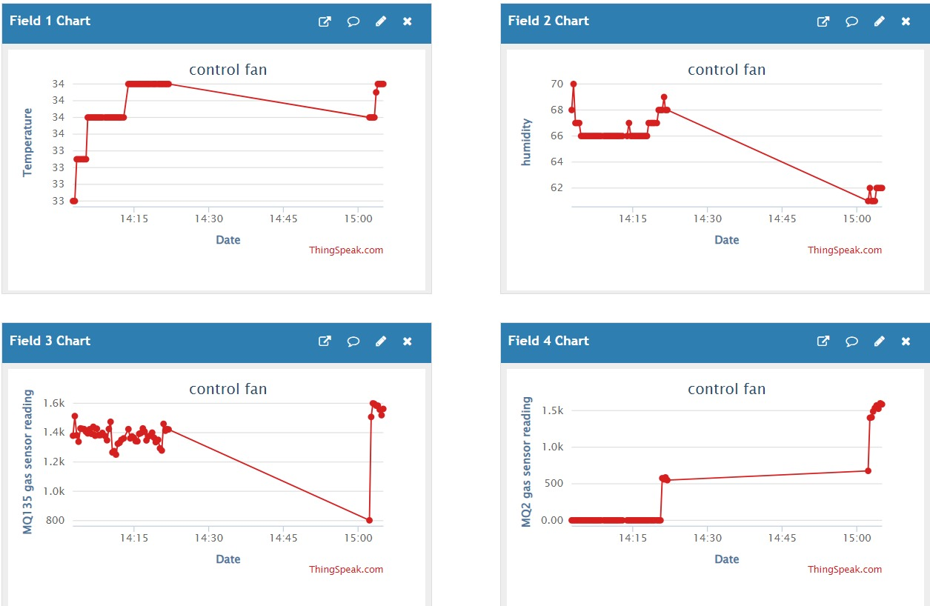 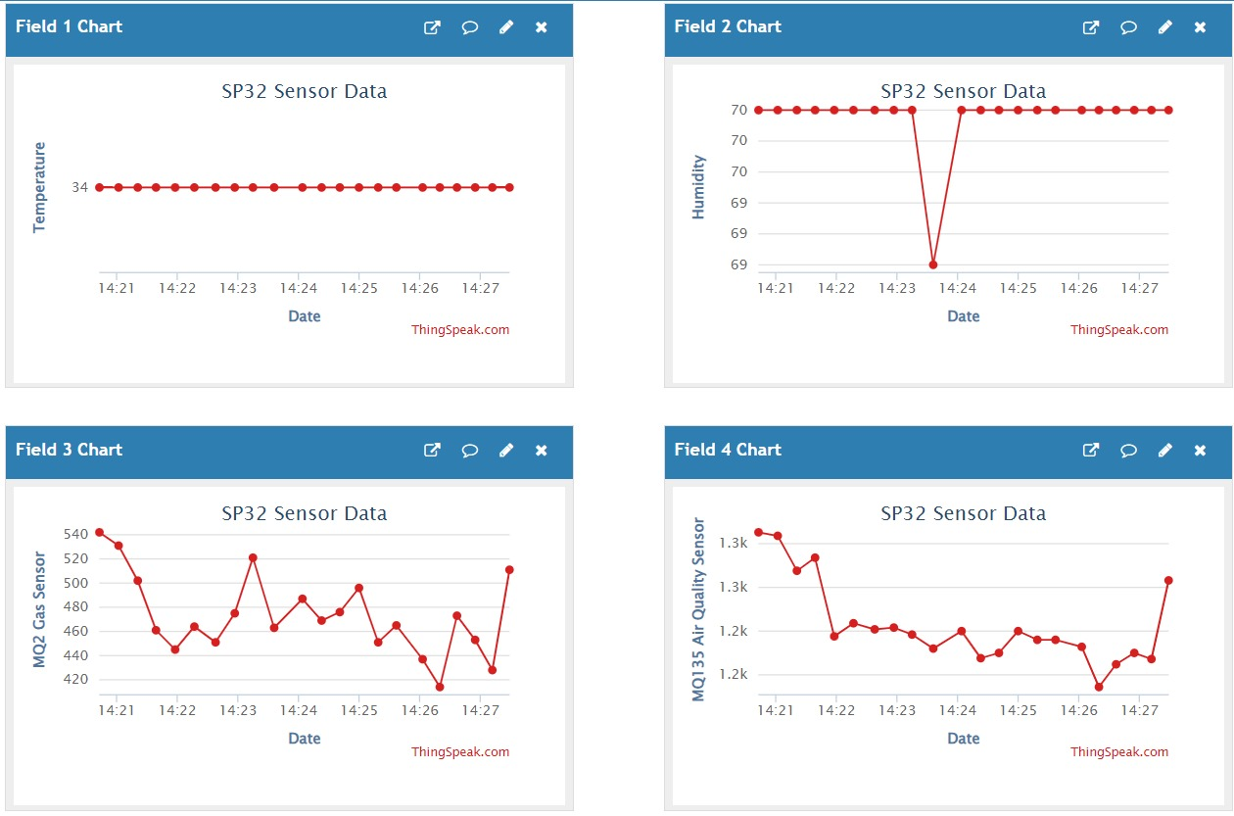

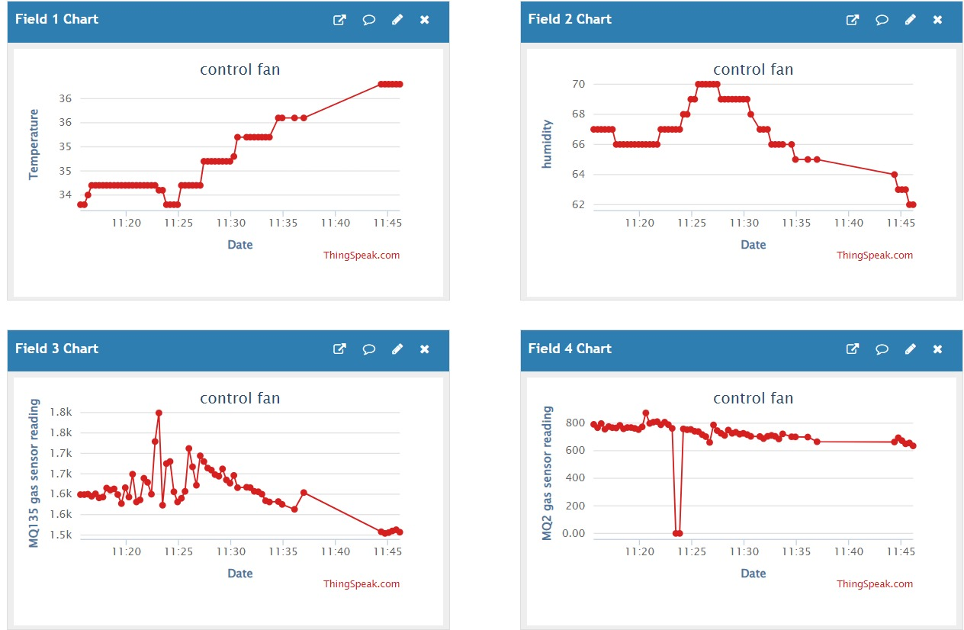

**Conclusion:**

The IoT-based Smart Onion Storage System represents a transformative solution in addressing the critical challenges faced in post-harvest management of onions. By effectively monitoring and regulating essential environmental parameters such as temperature, humidity, and gas concentrations, this innovative system significantly extends the shelf life of onions from a mere three months to an impressive ten months. This extension not only mitigates spoilage and decay but also enhances the overall quality of the stored produce, making it more appealing to consumers and ensuring that farmers can achieve higher market prices.

The integration of Internet of Things (IoT) technology allows for real-time data collection and analysis, empowering farmers and agribusinesses to make informed decisions regarding storage conditions. The automation capabilities of the system facilitate the maintenance of optimal storage environments with minimal manual intervention, thereby reducing labor costs and the potential for human error. This efficiency translates directly into increased profitability for stakeholders throughout the agricultural value chain.

Furthermore, the marketing strategy for the Smart Onion Storage System is designed to maximize adoption and engagement among target audiences, including farmers, agribusinesses, and government entities. By leveraging digital tools, social media, and content marketing, the strategy effectively communicates the system’s key benefits: reduced spoilage, increased profitability, and sustainable agricultural practices. Collaborations with agricultural institutions and government initiatives not only bolster credibility but also enhance outreach efforts, ensuring that the system reaches those who can benefit most.

Additionally, robust customer support and training programs are integral components of the marketing strategy, fostering strong relationships with users and encouraging feedback for continuous improvement. This ongoing engagement will help refine the system’s features and functionalities, making it even more valuable to its users.

Ultimately, the IoT-based Smart Onion Storage System is more than just a technological innovation; it represents a crucial step toward sustainable agricultural practices and food security. By significantly reducing food wastage, increasing farmer income, and promoting efficient resource utilization, this system has the potential to revolutionize the way onions and other perishable goods are stored and managed. In conclusion, the successful implementation and adoption of this system can lead to a more resilient and sustainable food supply chain, benefiting not only farmers and agribusinesses but also consumers and the environment as a whole

The IoT-based Smart Onion Storage System represents a transformative solution in addressing the critical challenges faced in post-harvest management of onions. By effectively monitoring and regulating essential environmental parameters such as temperature, humidity, and gas concentrations, this innovative system significantly extends the shelf life of onions from a mere three months to an impressive ten months. This extension not only mitigates spoilage and decay but also enhances the overall quality of the stored produce, making it more appealing to consumers and ensuring that farmers can achieve higher market prices.

The integration of Internet of Things (IoT) technology allows for real-time data collection and analysis, empowering farmers and agribusinesses to make informed decisions regarding storage conditions. The automation capabilities of the system facilitate the maintenance of optimal storage environments with minimal manual intervention, thereby reducing labor costs and the potential for human error. This efficiency translates directly into increased profitability for stakeholders throughout the agricultural value chain.

Furthermore, the marketing strategy for the Smart Onion Storage System is designed to maximize adoption and engagement among target audiences, including farmers, agribusinesses, and government entities. By leveraging digital tools, social media, and content marketing, the strategy effectively communicates the system’s key benefits: reduced spoilage, increased profitability, and sustainable agricultural practices. Collaborations with agricultural institutions and government initiatives not only bolster credibility but also enhance outreach efforts, ensuring that the system reaches those who can benefit most.

Additionally, robust customer support and training programs are integral components of the marketing strategy, fostering strong relationships with users and encouraging feedback for continuous improvement. This ongoing engagement will help refine the system’s features and functionalities, making it even more valuable to its users.

Ultimately, the IoT-based Smart Onion Storage System is more than just a technological innovation; it represents a crucial step toward sustainable agricultural practices and food security. By significantly reducing food wastage, increasing farmer income, and promoting efficient resource utilization, this system has the potential to revolutionize the way onions and other perishable goods are stored and managed. In conclusion, the successful implementation and adoption of this system can lead to a more resilient and sustainable food supply chain, benefiting not only farmers and agribusinesses but also consumers and the environment as a whole.

The marketing strategy for the IoT-based Smart Onion Storage System combines digital tools, partnerships, and direct sales to effectively reach and engage the target audience. By highlighting the system’s ability to extend shelf life, reduce spoilage, and increase profitability, the strategy emphasizes its value for farmers, agribusinesses, and government organizations alike. Through strategic partnerships and robust customer support, this approach aims to position the system as a leading solution for post-harvest storage challenges.

The IoT-based smart onion storage project is a forward-thinking solution to one of agriculture's longstanding problems. By implementing a system that monitors and adjusts temperature and humidity in real-time, this project aims to significantly reduce spoilage and extend the storage life of onions, leading to better food security, reduced waste, and enhanced profitability for farmers. This system can easily be adapted for other perishable crops, making it a versatile solution in the agricultural domain.

**Future development:**

The IoT-based Smart Onion Storage System has laid the foundation for a transformative approach to post-harvest storage, but there are numerous opportunities for future development to further enhance its functionality and broaden its applications. One potential avenue is the integration of advanced machine learning algorithms and artificial intelligence (AI) to optimize the system’s performance. By utilizing AI, the system could not only monitor and regulate environmental conditions but also predict potential issues such as spoilage or equipment failure before they occur, using historical data and real-time analytics. This predictive maintenance approach could significantly reduce downtime and improve overall system efficiency, ensuring that onions remain in ideal storage conditions at all times. Moreover, AI could be used to continuously adjust storage parameters based on external factors, such as weather conditions or market demand, providing dynamic and responsive storage management.

In addition to AI integration, the system could benefit from incorporating blockchain technology to enhance transparency and traceability within the supply chain. With blockchain, each stage of the onion storage and distribution process could be recorded in a decentralized ledger, allowing stakeholders to track the produce’s journey from farm to market with full visibility. This would be especially valuable in cases where quality control and certifications are required, ensuring that onions are stored and handled in accordance with best practices. Blockchain could also empower farmers and suppliers to negotiate better prices, as they would have documented proof of the superior quality and extended shelf life of their produce, thanks to the IoT-based storage system.

Another future development could involve expanding the system's capabilities to accommodate a wider range of perishable goods beyond onions, such as potatoes, garlic, and other root vegetables, as well as fruits like apples and bananas. Each of these items requires specific storage conditions to prevent spoilage and maximize shelf life, and the system could be adapted to monitor and control the unique parameters needed for different types of produce. This versatility would not only broaden the system’s market but also make it an invaluable tool for farmers and agribusinesses dealing with a variety of crops.

Additionally, enhancing the IoT-based system’s user interface (UI) and user experience (UX) could make it more accessible and user-friendly, particularly for farmers with limited technical expertise. Future versions of the system could include intuitive mobile applications or voice-activated commands that allow users to monitor and adjust storage conditions remotely with ease. Incorporating multilingual support and personalized notifications based on user preferences could further improve the system’s usability and adoption among diverse groups of farmers.

Future development could also focus on making the system more energy-efficient and environmentally sustainable. By integrating renewable energy sources such as solar panels, the system could become less reliant on traditional power grids, making it more suitable for rural areas with unreliable electricity. In addition, using energy-efficient materials and components could reduce the system’s overall carbon footprint, aligning with global sustainability goals.

Lastly, collaboration with government bodies, agricultural research institutions, and international organizations could drive large-scale implementation of the IoT-based Smart Onion Storage System. Governments could incentivize farmers to adopt the technology by offering subsidies or grants, while partnerships with research institutions could lead to continuous innovation and refinement of the system. This collaboration could also help in addressing regulatory challenges and promoting widespread adoption, especially in developing countries where post-harvest losses are a significant concern. In conclusion, the future development of the IoT-based Smart Onion Storage System promises not only to improve the storage of onions but to revolutionize the broader agricultural storage landscape through AI, blockchain, energy efficiency, and enhanced usability, ensuring its global relevance and impact.